

**RICHARD BELL   
Church Safeguarding Officer**

Our Safeguarding Officer is the first person to speak to if you have any concerns around the welfare of a child or vulnerable adult.

You can contact Richard on **07934 871538** or email via **childsafeguarding@mail.com**

The following team members have completed safeguarding training: **Alan Bradford, Richard Bell, Carol Williams, Caroline Reed**

**LUCY PIKE  
Children’s Champion**

The Children’s Champion is here to be an advocate for all children in all areas of Parish life, making sure their views are heard and their needs are thought of.

You can contact Lucy on **01895 254307**

**dren’s Champion**

The Children’s Champion is here to be an advocate for all children in all areas of Parish life, making sure their views are heard and their needs are thought of.

**You can contact them on: xxxxxxxxxx**

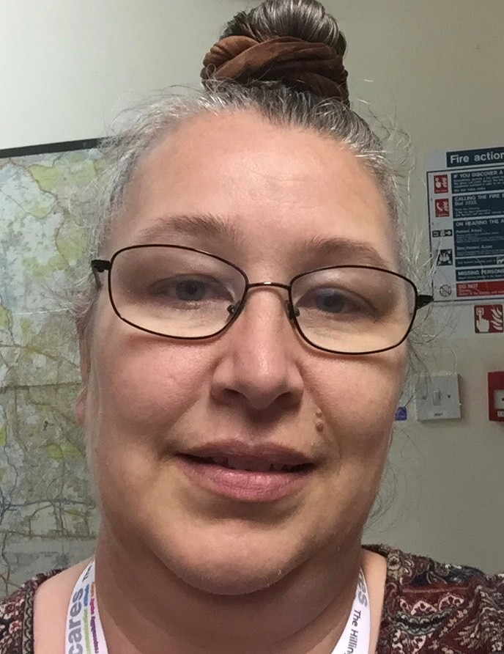

**Safeguarding Officer**

**Children’s Champion**

**Statement on Safeguarding Children and Adults at Risk**

Every person has a value and dignity, which comes directly from the creation of people in God’s image. Christians see this potential as fulfilled by God’s re-creation of us in Christ. Among other things this implies a duty to value all people as bearing the image of God and therefore to protect them from harm.

We commit ourselves to nurture, protect and safeguard all our members, particularly children, young people and adults at risk.

We recognise that safeguarding is the responsibility of the whole church.

We undertake to exercise proper care in the selection, appointment, training and support of those working with children or adults at risk.

We will respond without delay to concerns or allegations that a child or adult at risk may have been harmed, cooperating fully in any investigation.

We will challenge any abuse of power by anyone in a position of trust.

We will seek to offer pastoral care to anyone who has suffered abuse.

We will seek to offer pastoral care and support, including supervision and referral to the proper authorities, to any member of our church community known to have offended against a child, young person or adult at risk.

Please refer to the ***Parish Safeguarding Policy Statement, Diocesan Safeguarding Policy Promoting a Safer Diocese (2018)*** *and the National Church’s* ***Safeguarding Policies*** *and* ***Parish Safeguarding Handbook*** for more information.

Vicar: Rev’d Alan Bradford

Churchwarden: Rick Williams Churchwarden: Roy Munday



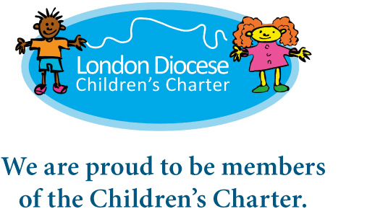



Important telephone numbers:

**Diocesan Safeguarding Advisers**: 020 7932 1224 [safeguarding@london.anglican.org](mailto:safeguarding@london.anglican.org) **Thirtyone Eight’s 24-hour helpline**: 0303 003 1111 **Family Lives:** 0808 800222

**Childline**: 0800 1111 **NSPCC**: 0808 800 5000 **Action On Elder Abuse:** 080 8808 8141

**National Domestic Violence Helpline**: 0808 2000 247 **Samaritans**: 116 123